Worksheet 5

Student Name: Aryan | UID:25MCI10082
Branch: MCA (AI&ML) | Section/Group: 1/A
Semester:2nd | Date of Performance: 01/03/2026
Subject Name: DBMS LAB | Subject Code: 25CAP-652

1. Aim of the Session
To gain hands-on experience in creating and using cursors for row-by-row processing in a database, enabling sequential access and manipulation of query results for complex business logic. (Company Tags: Infosys, Wipro, TCS, Capgemini)

2. Software Requirements
- PostgreSQL (Database Server)
- pgAdmin
- Windows Operating System

3. Objective of the Session
- Sequential Data Access: To understand how to fetch rows one by one from a result set using cursor mechanisms.
- Row-Level Manipulation: To perform specific operations or calculations on individual records that require conditional procedural logic.
- Resource Management: To learn the lifecycle of a cursor: Declaring, Opening, Fetching, and importantly, Closing and Deallocating to manage system memory.
- Exception Handling: To handle cursor-related errors and performance considerations during large-scale data iteration.

4. Practical / Experiment Steps

Prerequisite Understanding
- Students should first understand that cursors are used inside PL/pgSQL blocks for row-by-row processing, not in normal set-based SQL queries.
- Students should understand the difference between set-oriented SQL execution and procedural rowlevel execution.
- Students should create a table containing multiple records so that sequential row processing using cursors can be demonstrated.
- The table should contain:
- A unique identifier (Primary Key)
- A descriptive attribute (such as employee name or department)
- A numeric attribute (such as salary or experience) to apply conditional logic
- Students should understand the lifecycle of a cursor, including:
- DECLARE – defining the cursor query
- OPEN – executing the cursor
- FETCH – retrieving rows sequentially
- CLOSE – releasing the result set
- Students should be familiar with basic IF–ELSE logic for applying business rules during row processing.

5. Procedure of the Practical
- Start the system and log in to the computer.
- Open PostgreSQL software.
iii) Create and select the database.
Create database Practical5;

- Create table using DDL command.
CREATE TABLE employees (
emp_id SERIAL PRIMARY KEY,
emp_name VARCHAR(100),
salary NUMERIC(10,2),
experience INT );

- Insert records into the table.
INSERT INTO employees(emp_name,experience,salary) VALUES
('Amit',3,50000),
('Rohan',5,70000),
('Isha',2,45000),
('Sneha',4,60000),
('Anish',3,52000);

- Display all records.
select * from employees;
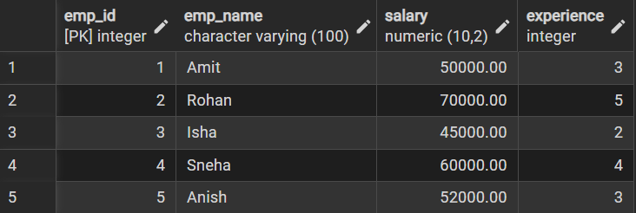

Step 1: Implementing a Simple Forward-Only Cursor
DO $$
DECLARE
emp_rec record;
emp_cursor cursor for
SELECT emp_id,emp_name,salary FROM employees;
BEGIN
OPEN emp_cursor;

LOOP
FETCH emp_cursor INTO emp_rec;
EXIT WHEN NOT FOUND;

RAISE NOTICE 'ID: %, Name: %, Salary: %',
emp_rec.emp_id, emp_rec.emp_name, emp_rec.salary;
END LOOP;
CLOSE emp_cursor;
END $$;
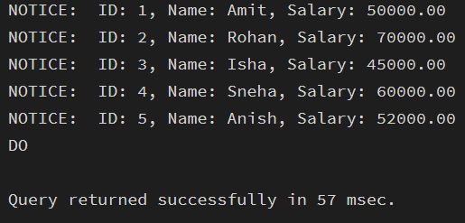

Step 2: Complex Row-by-Row Manipulation

do $$
declare
emp_rec record;
emp_cursor cursor for
select emp_id, experience, salary from employees;
begin
open emp_cursor;

loop
fetch emp_cursor into emp_rec;
exit when not found;

if emp_rec.experience >= 4 then
update employees
set salary = salary * 1.35
where emp_id = emp_rec.emp_id;

elseif emp_rec.experience >= 3 then
update employees
set salary = salary * 1.20
where emp_id = emp_rec.emp_id;

else
update employees
set salary = salary * 1.10
where emp_id = emp_rec.emp_id;
end if;

end loop;

close emp_cursor;
end $$;

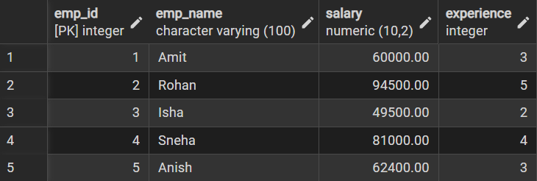

Step3: Exception and Status Handling
do $$
declare
emp_rec record;
emp_cursor cursor for
select * from employees where experience > 10;
begin
open emp_cursor;
fetch emp_cursor into emp_rec;
if not found then
raise notice 'No employees found with experience > 10.';
else
raise notice 'Employees exist.';
end if;

close emp_cursor;
end $$;

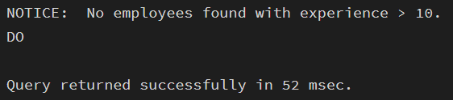

6. I/O Analysis (Input / Output) Input:
- Employee records inserted into a database table for row-by-row processing
- PL/pgSQL DO blocks containing cursor logic
- DECLARE, OPEN, FETCH, and CLOSE cursor statements
- Conditional IF–ELSE logic applied within cursor loops
- UPDATE statements executed based on experience or salary conditions
- Exception handling logic for empty result sets Output:
- Sequential row-by-row processing of employee records using cursor mechanism
- Display of employee details using FETCH operation
- Conditional salary updates based on defined business rules
- Notice messages generated during cursor execution
- Proper termination of cursor after processing all records
- Successful handling of empty result sets without runtime errors
- Correct execution of procedural SQL demonstrating cursor lifecycle

Screenshots of execution and obtained results are attached.

7. Learning Outcomes
- Cursor Implementation: Students will be able to design, implement, and manage cursors to solve row-wise processing problems.
- Lifecycle Mastery: Students will demonstrate the correct syntax for declaring, opening, fetching, and closing cursors.
- Error Prevention: Students will understand how to properly handle row-by-row processing exceptions and prevent memory leaks via deallocation.
- Analytical Thinking: Students will be able to apply cursor-based logic to solve realworld scenarios like multi-level payroll adjustments or data migrations.

